**HOTEL COMPETITOR ANALYSIS**

**Prepared by: Nur Laila Syamsi**

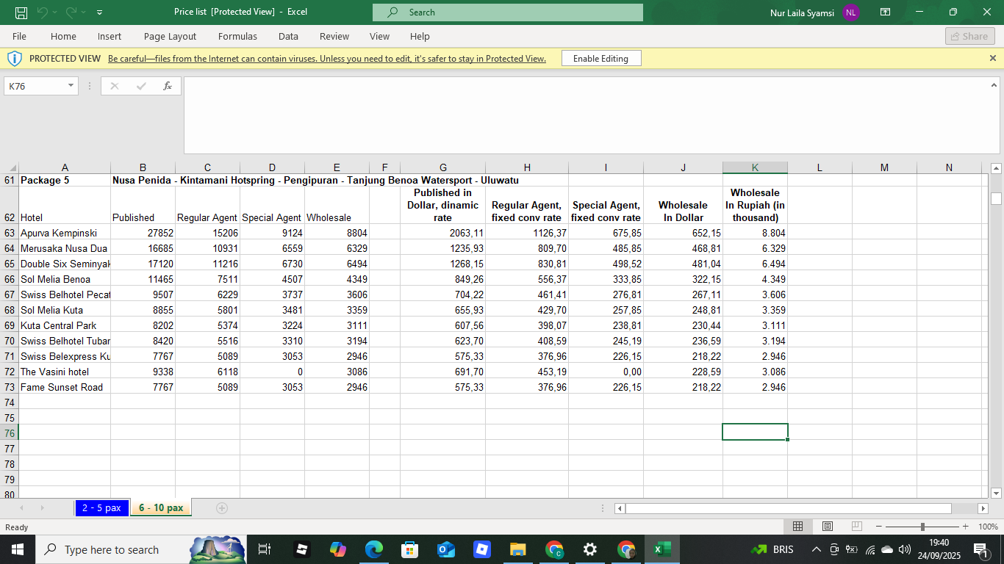

Based on the provided hotel price list, here is a competitor analysis that focuses on pricing strategy and market positioning.

**Hotel Competitor Analysis**

This analysis is based on the provided data, which details dynamic, fixed, and wholesale rates for several hotels in the Nusa Penida, Kintamani, Penglipuran, and Tanjung Benoa areas. The data highlights a tiered pricing structure that targets different types of booking agents.

**Pricing Strategy & Market Position**

The hotels can be categorized into different market segments based on their average pricing.

* **Premium/Luxury Segment:** **Apurva Kempinski** and **Menaka Nusa Dua** are positioned at the top of the price list. Apurva Kempinski, with a dynamic rate of over 2,000 USD, is a clear leader in the luxury category.
* **Mid-Range Segment:** Hotels like **Sol Melia Benoa**, **Kuta Central Park**, and **The Yasmin Hotel** fall into a competitive mid-range tier, with dynamic rates generally between 600 and 1,200 USD. This segment likely competes on a balance of price, location, and amenities.
* **Budget/Economy Segment:** Hotels such as **Fame Sunset Road** and **Swiss Belhotel Petal** appear to target the budget-conscious traveler, with the lowest rates on the list.

The significant price difference between the most expensive and least expensive hotel suggests a diverse market with options for every type of traveler.

**Analysis of Pricing Tiers**

The table reveals a consistent pricing strategy across all hotels, with a clear hierarchy for different booking channels:

* **Regular Agent:** This is the highest-priced rate, suggesting it's the standard commissionable rate for traditional travel agents.
* **Special Agent:** This rate is consistently lower than the Regular Agent rate, indicating it is likely reserved for specific travel agencies with high-volume partnerships.
* **Wholesale:** This is the lowest rate, designed for bulk bookings by large tour operators, wholesalers, or corporate clients. The low price is compensated by the high volume of business.

The presence of these tiered rates shows that each hotel is actively managing its revenue by offering different price points to various distribution partners. All prices are also converted to Indonesian Rupiah, which indicates a strong focus on both international and local markets.

**Key Insights & Limitations**

* **Competitive Landscape:** The analysis shows a highly competitive market with clear price-based segmentation. To compete, hotels must offer distinct value propositions that justify their price point.
* **Incomplete Data:** This analysis is limited to pricing. A full competitor analysis would require additional data on amenities, guest reviews, location advantages, and marketing strategies to fully understand the market and identify opportunities.

### Data Collection: Direct Phone Calls

To supplement our online research and gain a more complete picture of the market, we used **direct phone calls** to contact our key competitors. This technique was crucial for gathering real-time and unlisted data that is not available on public websites or booking platforms.

The process for this data collection method involved:

* **Preparation:** A standardized script was created with key questions about real-time availability, specific room types, special promotions, and amenities not detailed online.
* **Execution:** Calls were made to the reservations or front desk of each competitor. The information gathered was immediately documented to ensure accuracy.
* **Validation:** All data collected via phone calls was cross-referenced with online sources to verify consistency and identify any discrepancies.

This technique allowed us to obtain critical, up-to-the-minute details on pricing and availability. It also provided insight into the quality of customer service and allowed us to inquire about specific, non-advertised features like flexible booking policies or add-on services. This method was particularly effective for small, independent hotels that may not have extensive or updated online information.